

**Model No.：NV-368**

**Fabric Steamer**

**Instruction Manual**

Read this manual before using



Nvision Electrical Appliance Co., Ltd.

ADD：No. 13, Yuansheng Lane, Changzhen Industrial zone, Gongming Street, Shenzhen, Guangdong, China.

TEL：0755-27181965 29563475(Direct Line)

FAX：0755-27181952 P.C.：518106

WEBSITE：www.nvisions.cn

**Parts Illustration**

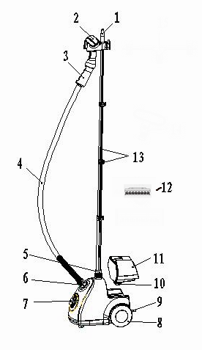 FIGURE 1

1. Top Hanger

2. Steam Nozzle

3. Handle

4. Hose

5. Pole Nut

6. Hose Connector

7. Steam Adjusting Knob

8. Wheel

9. Power Cord

10. Water Tank Cap

11. Water Tank

12. Fabric Brush

13. Telescope pole / Trigger

**Basic parameters**

|  |  |
| --- | --- |
| Model: | NV-368 |
| Voltage: | 220V, 50Hz |
| Wattage: | 500W - 1500W |
| Water Capacity: | 1.5L |
| Continuous Steam Time: | 150 – 45min |
| Power Cord length: | 190CM |

**Usage**

It can be widely used in home, garment industry or other place to clean or steam iron curtain, sofa, hotel and restaurant areas etc.

**WARNING**

Read this manual before using

* Use this fabric steamer only for its intended purpose as indicated in this manual.
* Before plugging power cord into electrical outlet, be sure that all electrical information on rating label agrees with your power supply.
* To reduce likelihood of circuit overload, DO NOT operate another high wattage appliance on the same circuit as this unit.
* Please settle it indoors while working. Do not use it outdoors or on wet floor.
* Please store the unit out of reach for children. Children are NOT allowed to operate it.
* Please unplug before clearing, removing the fabric steamer or when not in use.
* Do NOT use before filling water, and please watch carefully the water level while using to avoid any damages or reduce the using life of the unit for drying out.
* Do not wind or fold the steam hose, or put it on the floor.
* Please take care when using the appliance due to the emission of steam. Do not touch the hot plastic parts, hot water, or steam to avoid hurting.
* Please unplug unit and clean the unit till cool down completely for at least 30 minutes, then pour out the water inside the unit.
* Please pull the pole to move the unit. Pour out the water inside the unit and check the big wheel when there is any difficulty to move it.
* Please do not add water directly into the unit before unplug the unit.
* Please keep the unit away from flammable and explosive objects as well as stove.
* Do not leave the working unit alone without guard.
* Please do not fixing or alternate the unit by yourself. If there is any problem, please send it to the manufacturer or its service agent.
* Please do not immerge the unit, power cord and plug into water.
* Never yank power cord to disconnect from outlet; instead, grasp plug and pull smoothly to disconnect.
* When filling unit, only water should be used – other cleaning agents could damage unit or cause injury. Distilled or de-mineralized water is highly recommended, in order to extend the life length.
* Please be careful with hot steam emitting from the steam nozzle. Please unplug the steamer before adding water and cleaning.

**Key Functions**

● Generating high temperature steam of 100℃ in 40 seconds.

● Five levels to be chosen for different garment material.

● Huge capacity of water tank. The working time lasts 45-150minutes under five different power levels.

● Combining ironing, sterilizing, dust-removing function with deodorant.

● Power off automatically when over-heating and lacking of water with double security protection.

● The big wheel under bottom to help move.

● Adjustable, detachable telescopic pole.

6. Assemble Instructions

**TELESCOPIC POLE**

The Telescopic Pole is made up of four sections(Figure 2)

**•** TOP (SECTION 1)

**•** MIDDLE-TOP (SECTION 2)

**•** MIDDLE-BOTTOM (SECTION 3)

**•** BOTTOM (SECTION 4)

FIGURE 2



**ADJUSTING TELESCOPIC POLE**

In order to adjust the length of SECTIONS 1, 2 & 3 of the Telescopic Pole(figure 3):

**1.** Release extension lock directly below SECTION 1 by swinging hinge outward as shown. SECTION 1 can then be extended / retracted.

**2.** Once SECTION 1 is at desired length, close hinge to once again secure extension lock.

**3.** Repeat **STEPS 1 & 2** for SECTIONS 2 & 3 of the Telescopic Pole, using the extension lock directly below each of those sections.

FIGURE 3

**NOTE: It is recommended to extend Telescopic Pole to its full height during steamer operation; this will ensure optimal steam flow through the Hose.**

**CONNECTING POLE TOP**

1. Align Pole Top guide ridges with guide grooves on SECTION 1of Telescopic Pole(figure 4-A). Be sure to orient Pole Top so that Steam Nozzle Cradle faces toward front of unit. This will help to improve unit stability when heavy garments are hung from the Clothes Hanger Hook.

2. Unscrewing the pole nut and insert the pole in it, then screw to lock telescopic pole in pole base (Figure 4-B). Align two guide grooves on Telescopic Pole with guide ridges inside Pole Base.

3. Screw clockwise to lock Telescopic Pole in place (Figure – C). Telescopic Pole should now be secured to the Pole Base.

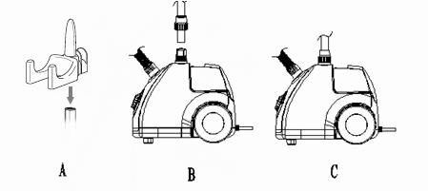FIGURE 4

**CONNECTING HOSE**

**1.** Place end of Hose onto threaded Hose Base.

**2.** Rotate coupling in clockwise direction until Hose is tightly secured onto Hose Base. Hand tightens only. Do not over-tighten.

**3.** Hang Steam Nozzle on specially designed Steam Nozzle Cradle.

**CAUTION: To prevent steam from causing bodily injury or damage to surfaces, always hang Steam Nozzle on Steam Nozzle Cradle when not in use. Do not lay Hose on the floor as condensation may build up, causing unwanted water droplets in the steam. Do not pull on the Hose with excessive force as this may damage it, resulting in a steam leak.**

**CONNECTING ACCESSORIES**

For versatile use, two kinds of accessories are available for the fabric steamer, which are the Fabric Brush and Lint Removal. Before connecting these accessories, please make sure the plug is off the outlet and there is no steam emitting from the Steam Nozzle.Do not try to connect these accessories while unit is emitting steam, as this can cause burns and injury.

**CONNECTING FABRIC BRUSH**

To attach the Fabric Brush to the steam nozzle, simply line up long peg on back of accessory with slot on face of steam nozzle (figure 5 -B). Press peg into slot firmly, until accessory is set securely in place.

**FILLING WITH WATER**

1. Please make sure the plug is off the electrical outlet before filling with water.

2. Settle the fabric steamer on flat floor.

3. Remove Water Tank from main unit. Holding Water Tank upside-down, unscrew and remove Valve Cap.

4. Fill Water Tank with water through Valve Cap hole and then replace Valve Cap.

5. Place Water Tank back onto main unit. The water will flow automatically to the fabric steamer.

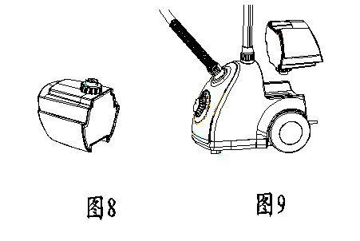FIGURE 6

**Operating the fabric steamer**

**NOTE: Be sure that Water Tank has been filled and, if desired, the Fabric Brush is connected before following these steps.**

**1.** For first time use, remove the protective plastic cover that is shipped on electrical plug. Plug power cord into a convenient 3-prong electrical outlet (figure A).

**CAUTION: This unit uses a grounded (3-prong) electrical plug. Use only in properly installed 3-prong electrical outlets. Do not attempt to alter plug or circumvent this safety feature in any way.**

**2.** Set Lighted On/Off Switch to “ON” position (figure 7 - A), and verify that switch is illuminated.

**3.** After approximately 45 seconds of heating time, unit will begin producing a flow of steam from Steam Nozzle.

**NOTE: It is common for the unit to produce gurgling sounds and small amounts of water during the first few minutes of steaming. This is due to water condensation inside cold Hose, and should be reduced as the Hose heats up. Pointing Steam Nozzle downward and shaking it may help to remove excess water from Hose more quickly.**

4. Once steam flow is steady and excess condensation has been removed from Hose, you may proceed with your steaming tasks.

**CAUTION: Always be sure that Steam Nozzle is pointed in a safe direction (away from yourself, other people, pets and plants) when steaming.**

5. When you are finished using the fabric steamer, immediately unplug power cord from electrical outlet.

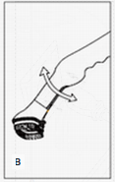FIGURE 7

**Removing mineral build-up**

A common maintenance need for steam appliances is the removal of build-up caused by high mineral content in many municipal water supplies. This mineral build-up may limit the effectiveness and reduce the life of your fabric steamer.

**To remove mineral build-up:**

1.Unplug power cord from electrical outlet. Allow unit to cool completely.

2. Remove Water Tank from unit. Unscrew Valve Cap

3. Drain all remaining water from Water Tank. Open Drain Plug and drain all remaining water from Water Reservoir. Securely replace Drain Plug.

4.Pour a mixture of vinegar and water (1:1) into from the Hose Connector until it fills the water reservoir halfly.

5. If the hose is stocked. Please pour the mixture of vinegar and water (1:1) into the water reservoir below the water tank.

6. Allow vinegar to flow into Water Reservoir and soak for 1-2 hours. After that, plug power cord into an electrical outlet. Allow unit to steam until no mixture liquid remains.

7. Tilt unit to drain water out from hose connector.

8. Pour fresh water into water tank and from the hose connector. Refill and repeat as necessary until vinegar odor has completely dissipated.

9. Place the water tank back onto main unit. Allow all fresh water to flow into Water Reservoir and be steamed out.When finished, unplug power cord from electrical

outlet.

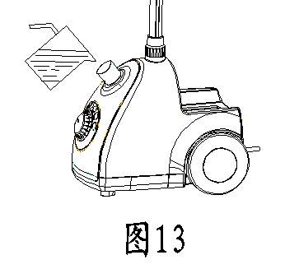

**FIGURE 8**

**Proper storage**

1. Unplug power cord from electrical outlet.

2. Allow unit to cool (at least 30 minutes for complete cooling).

3.Remove Water Tank from unit. Drain water out of water tank.

4. Remove the hose and tilt the unit to drain water out of it.

5. Remove the telescope pole.

6. Drain water out of the water reservoir to keep dry.

7. Securely replace empty Water Tank back onto main unit.

8.Replace the telescope pole and hose.

9. Hang the Steam Nozzle onto the hook.

10. Settle the unit in dry and cool place to store.

11. If it could not be used for a long time, the unit must be dried totally and power cord bind orderly and every accessory disconnect. Store this unit at dry and cool place.

**CAUTION: To use distilled or de-mineralized water when using your fabric steamer to minimize mineral build-up. A regular clearance of removing any deposits that form is helpful to extend life length.**

**Troubleshooting**

|  |  |  |
| --- | --- | --- |
| PROBLEM | POSSIBLE CAUSE | SOLLUTION |
| Unit fails to heat up. Lighted On/Off Switch **DOES NOT** illuminate when set to “ON” position. | Unit is not plugged in. | Plug power cord into electrical outlet. |
| Household circuit breaker / ground fault interrupter has tripped or blown a fuse. | Reset circuit breaker / ground fault interrupter, or replace fuse. For assistance, contact a licensed electrician. |
| Unit fails to heat up. Lighted On/Off Switch **DOES** illuminate when set to “ON” position. | No water in unit. | Turn off the power and refilling unit with water. |
| Mineral build-up in unit. | Refer to Mineral Build-up section  for cleaning procedure. |
| Steam / water drips from Steam Nozzle. | Condensation build-up inside of Hose. | Some gurgling is a natural effect of the steaming process. For dripping water, point Steam Nozzle downward and shake thoroughly to remove excess water droplets. |
| Excessive gurgling in Hose. | Condensation build-up inside of Hose. | Some gurgling is a natural effect of the steaming process. For excessive gurgling, point Steam Nozzle downward and shake thoroughly to remove excess water droplets. |
| Steam output is weak or intermittent. | Mineral build-up in unit. | Refer to Mineral Build-up section  for cleaning procedure. |